Including Banks Debt & Money in Macroeconomics (draft)
“It ain't what you don't know that gets you into trouble. It's what you know for sure that just ain't so.” (Mark Twain)
Nobel Laureate and INET Scholar Joe Stiglitz recently pointed out the anomaly that the overwhelming majority of macroeconomic models ignore the role of credit:
This might seem obvious. But a focus on the provision of credit has neither been at the centre of policy discourse nor of the standard macro-models. We have to shift our focus from money to credit. In any balance sheet, the two sides are usually going to be very highly correlated. But that is not always the case, particularly in the context of large economic perturbations. In these, we ought to be focusing on credit. I find it remarkable the extent to which there has been an inadequate examination in standard macro models of the nature of the credit mechanism. There is, of course, a large microeconomic literature on banking and credit, but for the most part, the insights of this literature has not been taken on board in standard macro-models. (Guerrero and Axtell 2013)
The practice of modeling the macroeconomy without considering the role, not only of credit, but of money itself, has been commonplace in economics. Even Keynes argued that macroeconomics modeling could ignore the technical details of money:
whilst it is found that money enters into the economic scheme in an essential and peculiar manner, technical monetary detail falls into the background. A monetary economy, we shall find, is essentially one in which changing views about the future are capable of influencing the quantity of employment and not merely its direction. But our method of analysing the economic behaviour of the present under the influence of changing ideas about the future is one which depends on the interaction of supply and demand, and is in this way linked up with our fundamental theory of value. We are thus led to a more general theory, which includes the classical theory with which we are familiar, as a special case.” (Keynes 1936, pp. xxii-xxiii. Emphasis added)
Though I regard modern “New Keynesian” DSGE (“Dynamic Stochastic General Equilibrium”) models as irredeemably erroneous in many other ways (Keen 2011, Chs 9, 10, 12), in one sense they are simply a continuation of this non-monetary tradition in economics. Even recent papers that attempt to model debt do so by abstracting from both money and banks (see for example Eggertsson and Krugman 2012, p. 1474, in which "borrowing and lending take the form of risk-free bonds denominated in the consumption good")—with the notable exception of Benes and Kumhof (Benes and Kumhof 2012).
In this paper I will argue that this tradition is fundamentally misguided, that macroeconomics must include the “technical monetary detail” of how banks create money and how this in turn affects the macroeconomy, and that this now an eminently feasible goal.

Loanable funds and the non-importance of aggregate private debt
The key argument advanced today by New Keynesian economists for not considering money and debt is that lending has no macroeconomic consequences—except during extraordinary events like those of today where the “zero lower bound” applies—because of the accounting truism that “one person’s liability is another person’s asset” (Eggertsson and Krugman 2012). From this truism, the deduction is made that debt therefore represents no more than a redistribution of spending power between lender and borrower, and can generally be ignored because the borrower’s increase in spending power is cancelled out by the lender’s decrease. This was the reason that Bernanke gave for the lack of attention given to Irving Fisher’s “Debt-Deflation Theory of Great Depressions” (Fisher 1933)
“Fisher's idea was less influential in academic circles, though, because of the counterargument that debt-deflation represented no more than a redistribution from one group (debtors) to another (creditors). Absent implausibly large differences in marginal spending propensities among the groups, it was suggested, pure redistributions should have no significant macro-economic effects…” (Bernanke 2000, p. 24. Emphasis added)
The same case is made by Eggertsson and Krugman when they justify including debt (though not money or banks) in their recent DSGE model: debt matters only when there are distributional factors that make it matter:
to a first approximation debt is money we owe to ourselves… Ignoring the foreign component, or looking at the world as a whole, the overall level of debt makes no difference to aggregate net worth—one person’s liability is another person’s asset. It follows that the level of debt matters only if the distribution of that debt matters, if highly indebted players face different constraints from players with low debt. (Eggertsson and Krugman 2012, p. 1471. Emphasis added)

The nature of money
The Circuitist School economist Graziani, on the other hand, gave good reasons why the aggregate level of private debt does matter—and why banks, debt and money must therefore be included in macroeconomics. Starting from first principles about what money is—in order to delineate the differences between a barter system and a monetary economy—Graziani argued that money cannot be treated as a commodity since “an economy using as money a commodity coming out of a regular process of production, cannot be distinguished from a barter economy”. This led to the first of three conditions for money, that “A true monetary economy must therefore be using a token money”.
Secondly, to be money this token “has to be accepted as a means of final settlement”, to distinguish it from credit, in which goods are transferred in return for an enduring debt relationship between buyer and seller—as when “goods are traded against promises of payment such as bills of exchange”. Thirdly, money could not grant “an unlimited privilege of seignorage” to the buyer. Graziani concluded that:
The only way to satisfy those three conditions is to have payments made by means of promises of a third agent, the typical third agent being nowadays a bank. When an agent makes a payment by means of a cheque, he satisfies his partner by the promise of the bank to pay the amount due. Once the payment is made, no debt and credit relationships are left between the two agents. But one of them is now a creditor of the bank, while the second is a debtor of the same bank.” (Graziani 1995, p. 518)
This makes banks an essential part of economics, since any monetary payment “must therefore be a triangular transaction, involving at least three agents, the payer, the payee, and the bank”. In combination with the Post Keynesian proposition that bank loans create deposits (Moore 1979), Graziani’s vision of a monetary economy gives a good reason why the level of debt does matter for macroeconomics at all times—and not only during a “Liquidity Trap” (Eggertsson and Krugman 2012, p. 1477). The stock of money in circulation is the sum of the liabilities of the banking sector to the rest of the economy, and an increase in the level of debt causes an equivalent increase in the amount of money in circulation. In contrast, the New Keynesian bank-less vision of lending cannot cause a change in the stock of money (even if money as they might define it were included in their models, which it is not!).

Comparing Loanable Funds and Endogenous Money
The difference between the New Keynesian “Loanable Funds” vision of lending and the Post Keynesian “Endogenous Money” vision can easily be illustrated in my Open Source monetary macroeconomic modeling program Minsky.(the development of which has been funded by both INET and crowd funding via Kickstarter). New Keynesians portray lending as a transfer of existing money between “Patient” and “Impatient” agents:
when debt is rising, it’s not the economy as a whole borrowing more money. It is, rather, a case of less patient people … borrowing from more patient people. The main limit on this kind of borrowing is the concern of those patient lenders about whether they will be repaid, which sets some kind of ceiling on each individual’s ability to borrow.” (Krugman 2012, pp. 146-147, emphasis added)
This can be modeled in a monetary economy (as Graziani defines it) by modeling not bank lending, but lending between different agents on the Liability side of the banking system’s ledger. Using Eggertsson and Krugman’s terminology, “Patient” agents lend by transferring some of the banking sector’s liabilities (their deposits) to “Impatient” agents (see Figure 1).
Figure 1: Loanable Funds as transfer of bank liabilities from Patient to Impatient Agents
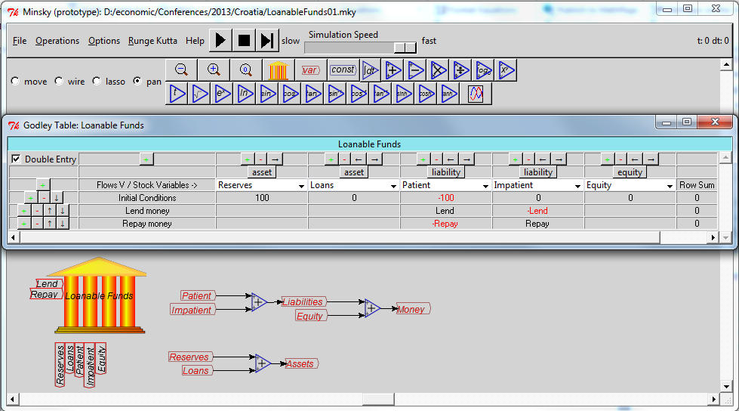
Figure 1 uses the financial accounting component of Minsky—known as the “Godley Table”—which follows the double-entry accounting conventions that any agent’s assets are shown as positive amounts while liabilities are shown as negatives. Since we are looking at this system from the perspective of the Banking sector, Reserves and Loans are shown as positive, while Liabilities and Equity are shown as negative. A transfer of liabilities from Patient to Impatient agents therefore involves a positive entry in Patient’s account, which reduces the Banking sector’s liabilities to Patient, and a negative entry in Impatient’s, which increases the Banking sector’s liabilities to Impatient.
The equations of motion of this system are shown in Equation . Obviously, bank-less lending does not alter the amount of money in existence: lending and repayment simply transfer the existing stock of money between the two classes of agents:
Graziani instead sees lending as occurring between the Banking sector and the Firm sector (with the firm sector’s objective in borrowing money being to hire workers to work in its factories). Portraying simply lending and repayment of loans in this model yields Figure 2 and Equation .
Figure 2: Endogenous money as lending by the Banking sector to the Firm sector
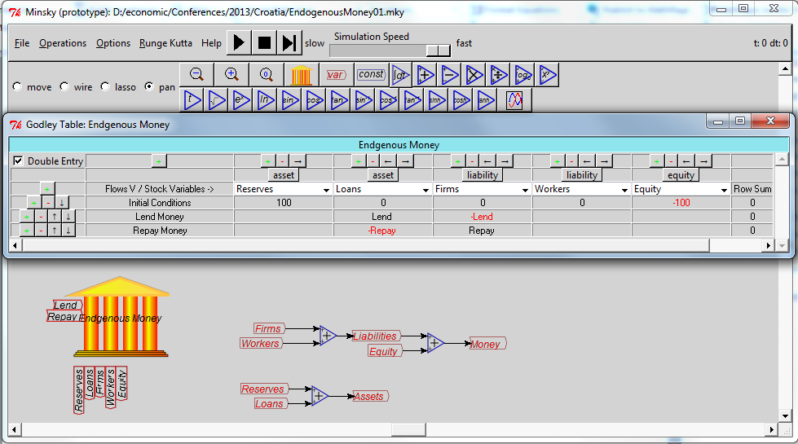
This model, which obeys the truism that “one person’s liability is another person’s asset” just as much as does the Loanable Funds bank-less model, clearly shows that net lending will increase the money supply (and net repayment of loans will reduce it):
Contra New Keynesian economics therefore, the aggregate level of lending clearly does have macroeconomic consequences, if the “Endogenous Money” view of the functioning of the credit system is correct. On this there can be little doubt: Loanable Funds dominates economic textbooks and theory, but Endogenous Money dominates reality.

The Mythical Money Multiplier
The Neoclassical “Loanable Funds” model of lending asserts the “Money Multiplier” mode of money creation (which is rather schizophrenic, since this acknowledges the role of banks as deposit-takers and loan-makers, and yet their macroeconomic models remain bank-less). Though banks are acknowledged to be able to create loans and deposits and hence money, the money supply is seen as being under the control of the Federal Reserve via the twin determinants of Central Bank creation of the money base (MB), and control of the Required Reserve Ratio (RRR). If the Reserves increases base money by ΔMB, then an iterative process of holding a fraction of the increased reserves, new lending, and new deposits will lead over time to the money supply growing by . In this model, an increase in reserves is initiated by the Reserve and precedes loans by (and deposits in) the private banking system.
The archetypal statement of the opposing endogenous money view, which rejects the Money Multiplier model, was given by Alan Holmes, the then senior vice-president of the New York Federal Reserve, in his unsuccessful attempt to prevent the adoption of Monetarist policies in the late 1960s. Given the persistence of the Money Multiplier model, Holmes’s practical dismissal of it is worth quoting at length:
The idea of a regular injection of reserves—in some approaches at least—also suffers from a naive assumption that the banking system only expands loans after the System (or market factors) have [sic.] put reserves in the banking system. In the real world, banks extend credit, creating deposits in the process, and look for the reserves later. The question then becomes one of whether and how the Federal Reserve will accommodate the demand for reserves. In the very short run, the Federal Reserve has little or no choice about accommodating that demand; over time, its influence can obviously be felt.
In any given statement week, the reserves required to be maintained by the banking system are predetermined by the level of deposits existing two weeks earlier. Since excess reserves in the banking system normally run at frictional level … the level of total reserves in any given statement week is also pretty well determined in advance. Since banks have to meet their reserve requirements each week (after allowance for carryover privileges), and since they can do nothing within that week to affect required reserves, that total amount of reserves has to be available to the banking system. (Holmes 1969, pp. 73-74. Emphasis added)
Given this institutional arrangement—that Required Reserves are determined by pre-existing level of deposits—then it is little wonder that empirical research has confirmed that the relation between Base Money and Credit Money is the reverse of that argued in the Money Multiplier model (O'Brien 2007 reports that this time delay is now 30 days. See Table 12, p. 52). The pioneering empirical work was done by the Post Keynesian economist Basil Moore (Moore 1979; Moore 1983; Moore 1988; Moore 1988; Moore 1997; Moore 2001), but the most instructive results come from none other than Real Business Cycle developers Kydland and Prescott. One of the many findings to question Neoclassical dogma in this empirical paper (“The purpose of this article is to present the business cycle facts in light of established neoclassical growth theory… We find these features interesting because the patterns they seem to display are inconsistent with the theory”) was the result that credit money led base money:
There is no evidence that either the monetary base or M1 leads the cycle, although some economists still believe this monetary myth. Both the monetary base and M1 series are generally procyclical and, if anything, the monetary base lags the cycle slightly […] The difference in the behavior of M1 and M2 suggests that the difference of these aggregates (M2 minus M1) should be considered […] The difference of M2–M1 leads the cycle by even more than M2, with the lead being about three quarters […]
The fact that the transaction component of real cash balances (M1) moves contemporaneously with the cycle while the much larger nontransaction component (M2) leads the cycle suggests that credit arrangements could play a significant role in future business cycle theory. Introducing money and credit into growth theory in a way that accounts for the cyclical behavior of monetary as well as real aggregates is an important open problem in economics. (Kydland and Prescott 1990, pp. 4, 15)
In a provocatively titled Federal Reserve research paper (“Money, Reserves, and the Transmission of Monetary Policy: Does the Money Multiplier Exist?”) written in the aftermath of the financial crisis, Carpenter and Demilarp affirm that the neat and plausible Money Multiplier model is empirically wrong:
Since 2008, the Federal Reserve has supplied an enormous quantity of reserve balances relative to historical levels as a result of a set of nontraditional policy actions. These actions were taken to stabilize short-term funding markets and to provide additional monetary policy stimulus at a time when the federal funds rate was at its effective lower bound. The question arises whether or not this unprecedented rise in reserve balances ought to lead to a sharp rise in money and lending. The results in this paper suggest that the quantity of reserve balances itself is not likely to trigger a rapid increase in lending […] the narrow, textbook money multiplier does not appear to be a useful means of assessing the implications of monetary policy for future money growth or bank lending. (Carpenter and Demiralp 2010, p. 29. Emphasis added)

Reserves in the endogenous money real world
A realistic if stylized view of the actual role of reserves in the endogenous money real world is shown in Figure 3, in which a Buyer purchases goods from a Seller using both cash and credit. There are three banks in the model—a Central Bank, a Buyer’s Bank, and a Seller’s Bank.
The cash purchase involves the flow of Cash from the Buyer’s account D_{B} at Buyer Bank to the Seller’s account D_{S} at Seller Bank. For that flow to happen there also has to be a transfer from the Buyer Bank’s reserve account at the Central Bank (R_{BB}) to the Seller Bank’s account (R_{SB}).
With excess reserves normally at frictional levels (as Holmes pointed out), it is quite possible that even the cash purchase by a Buyer could cause the Buyer’s Bank to breach its reserve requirements (or even to have a negative balance). If the Central Bank insisted that sales could only go ahead if the Buyer’s Bank had sufficient excess reserves to allow it, then the Buyer’s cash purchase would be voided—even though the Buyer had sufficient funds in his account. This is the basis of Holmes’s observation that the Reserve is relatively powerless in the short term: to exert its power would undermine the public’s trust in banks as means of payment.
The model also shows that the credit card transaction creates both a new loan (in the Buyer’s Bank) and new money (in the Seller’s Bank). The credit transaction is shown in two steps: firstly the Buyer accesses some of the unused credit limit in his credit card account by the flow Card. This increases the loans of Buyer Bank (L_{BB}) amount in the buyer’s deposit account D_{B}, matched by an increase in the Buyer’s deposit account (D_{B}). Then the additional money is used to buy the product by a transfer of the flow Card from the Buyer’s account D_{B} to the Seller’s account D_{S}. This again requires a transfer of reserves from Buyer Bank’s account at the Central Bank (R_{BB}) to the Seller Bank’s account (R_{SB}).
If this transaction resulted in Buyer Bank breaching its reserve requirements, it could either borrow the reserves from Seller Bank—which has clearly accumulated excess reserves—or from the Central Bank. Again, if the Central Bank failed to provide these funds, the Buyer’s quite legitimate purchase could be voided. As Holmes emphasized, the Central Bank has no choice but to provide the additional reserves, should they be required.
Figure 3: Cash and credit purchases and reserve transfers in 3 bank system
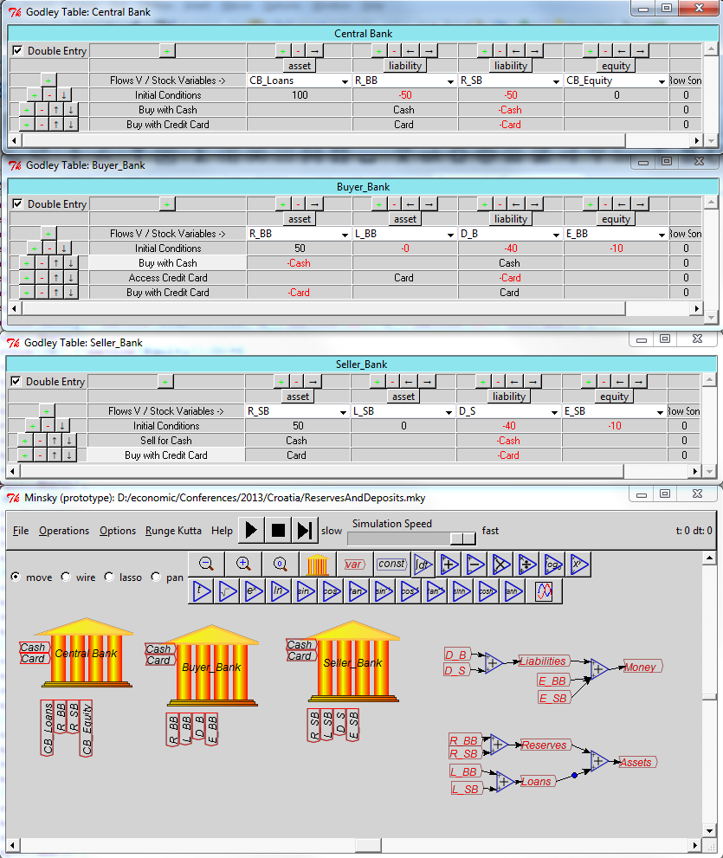
Equation shows the dynamics prior to the creation of new reserves, and illustrates that the creation of a new loan also creates new money—and this adds to aggregate spending power.
This simple example illustrates why the overwhelmingly dominant practice of Central Banks is to have lagging rather than leading reserve requirements, and why Loans create Deposits and drive Reserves, rather than the other way round as in the Mythical Money Multiplier.
If we now add some simple numerical dynamics to these symbolic monetary examples, we can see why the Neoclassical “banks, debt and money don’t matter in macroeconomics” position is vitally dependent on the neat, plausible but wrong Loanable Funds model—and why banks, debt and money matter a great deal in macroeconomics in the empirically accurate Endogenous Money perspective.

Loanable Funds with Implicit Production
The next model puts flesh on the Neoclassical argument that aggregate private debt, and changes in debt dynamics, don’t matter in macroeconomics—as indeed they don’t in a Loanable Funds world.
“Impatient” is now assumed to be the firm sector—as in the Endogenous Money model—and is borrowing from “Patient” in order to hire workers to produce output, which is then sold to Patient agents and Workers.
Figure 4: Loanable funds with implicit production
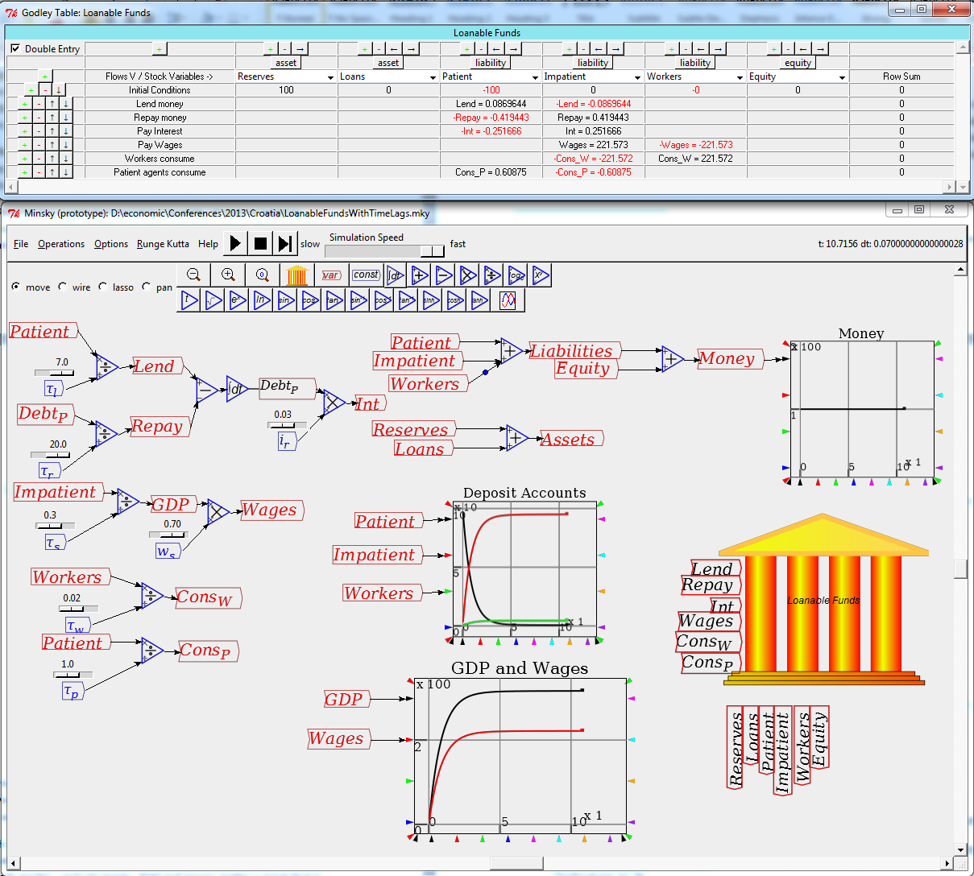
Production and distribution are implicitly modeled as a turnover period between the outlay of expenditure (on wages, etc.) and the receipt of payments, using the time constant τ_{S}. Since “Impatient agents” are the firm sector, the annual turnover in this account is equivalent to GDP. Wages are then GDP multiplied by workers’ share of output w_{S}. Long-run GDP is thus determined by the amount of money that accumulates in Impatient’s account and the turnover period, and drastic variations to lending behavior have very little impact on this amount. Crucially, changes to lending parameters have no impact on the amount of money in the model, which remains constant throughout.
Equation shows the new equations added to the model in equation —as well as the pivotal equation that the rate of change of the money stock is zero.

Endogenous Money with Implicit Production
Whereas changing the parameters determining lending and repayment has only trivial effects in the Loanable Funds model, they have dramatic impacts in the Endogenous Money model, because they change the rate of growth of the money stock (see Figure 5).
Figure 5: Endogenous money with implicit production
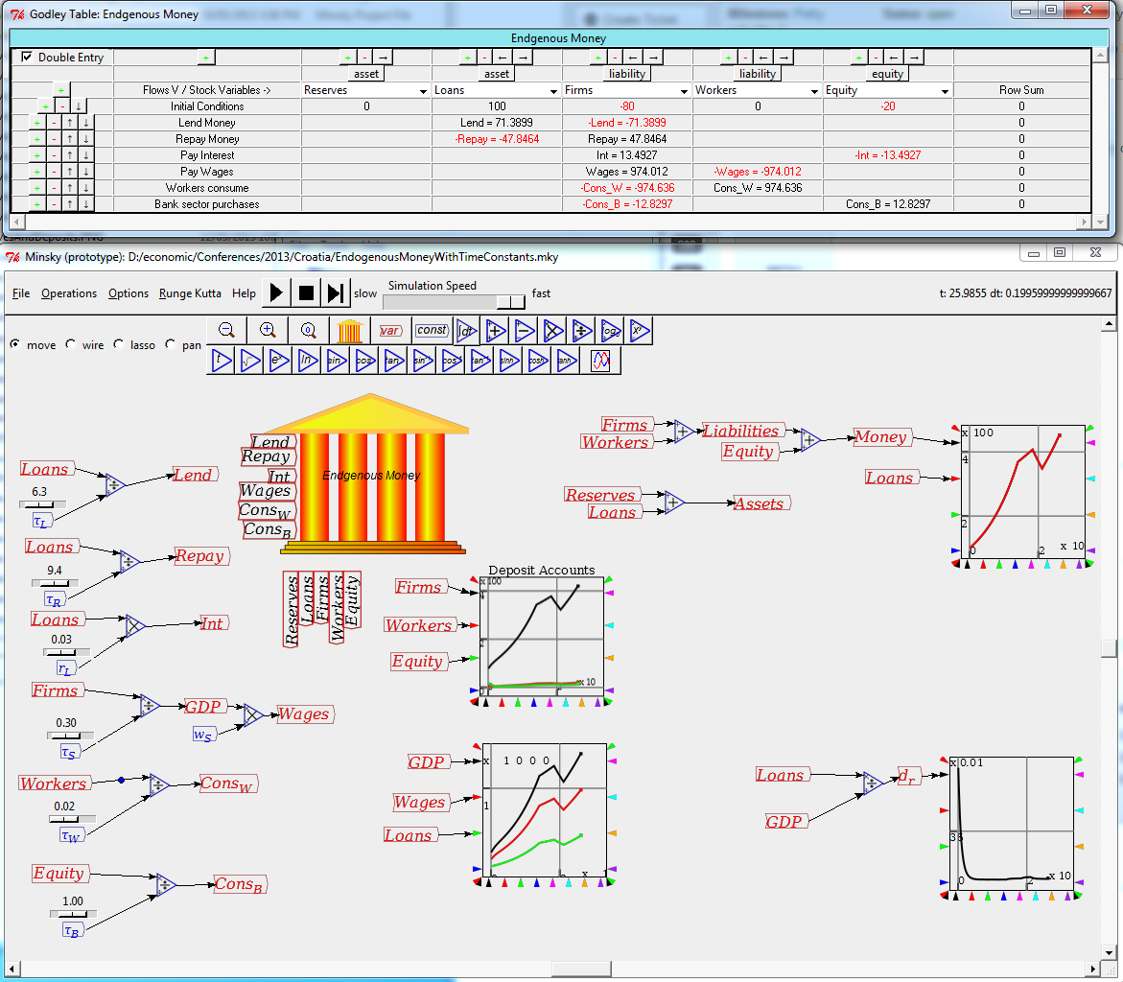
Equation shows the new equations added in the model to those in equation , in addition to the crucial equation that the rate of change of money stock is a function of the difference between the creation of new loans and the repayment of old ones.

Endogenous money and effective demand
Figure 5 also illustrates a key consequence of endogenous money: the creation of new money via the creation of new debt adds to aggregate demand above and beyond that from current incomes alone, so that in a monetary economy aggregate demand is income plus the change in debt.
This is entirely consistent with sectoral balances—as the model also demonstrates, since it is innately stock-flow consistent (any stock-flow errors would be shown by the Row Sum function in the Godley Table being non-zero; since it is zero in all rows, then as required for sectoral balance, all flows “come from somewhere and go somewhere” Godley and Lavoie 2005, p. 243). Confusion over this point emanates from confusing ex-post accounting identities—in which recorded expenditure must equal recorded income—with ex-ante sources of demand that include both income and newly created (and expended) money.
Hopefully a graphical illustration can clarify this issue. Figure 6 shows a stylized picture of income and expenditure running at a constant $1 billion per day, with a debt-financed expenditure of $100 million at time d. The effect of the loan is to bump this expenditure flow up instantaneously by an amount exactly equal to $100M/day at time d (assuming the newly created money is instantly spent).
Figure 6: Debt as a discontinuous injection into the flow of income & expenditure
1bn p.d.
1.1bn p.d.
d
Y,E
Y(t),E(t)
{ΔD(d)=100mn/day
0
24
d-3
d+3
t
Breaking this down into its separate flows of income and expenditure, Income (Y) is equal to $1bn/day up to and including time d, after which instant it is equal to $1.1bn/day. Expenditure (E) is equal to $1bn/day up to but not including time d; from and after time d, expenditure is equal to $1.1bn/day. Therefore Y and E are equal to each other at all times except time d, when Y is $1bn/day and E is $1.1bn/day:
Ex-post measurement of Y and E over any time period, including a time period in which d occurs, will find that Y and E are identical, because the change in debt increases them both by the same amount. For example, if you measure them from 3 hours before the debt injection to 3 hours after the debt injection you get total income = total expenditure = $125M + $137.5M = $262.5M. Of course this is more than the $250M that you would get for a 6 hour period without a debt injection, so the debt injection changed the value of the measurement (which is the integral of the lines from the start of the measurement to the end date), but it changed it by the same amount ($25M=$100M/day * ¼ day) for both income and expenditure.
Of course in real life all new debt is not added at one instant during a day, but at many different asynchronous times during a day. The same principle applies: at each such instant, expenditure and income will differ, while when measured over a time period including such instants, recorded income and recorded expenditure will be identical.

Endogenous money and effective supply
The inclusion of change in debt in the sources of expenditure also necessitates incorporating finance into macroeconomics—since a major (if not the major) use of borrowed money today is in the purchase of financial assets. Equation shows a stylized statement of the relationship between monetary effective demand and the effective supply of both goods (C+I) and net turnover on asset markets (A).
Net turnover on asset markets can be factored into the price level of assets (P_{A}) times the quantity of assets (Q_{A}) times the proportion of assets that are turned over in a given time period (T_{A}):
The change in aggregate demand therefore includes as a component the acceleration of debt, and this will be related to both change in demand for goods and services and change in asset markets:
This clearly results in a major revision of macroeconomics, which has been based on the proposition that income equals expenditure in all schools of thought to date. The need for such a revision is obvious when one applies this concept to the empirical data. It explains what no other perspective can explain: why the “Great Moderation” occurred, why it gave way to the “Great Recession” (which I expect future economists will call the Second Great Depression), and why the severity of this downturn was far milder (for the USA) than the Great Depression, even though the cause was equivalent in scale.

Empirical evidence on the change in debt & economic activity
Relationships between change in the aggregate level of debt and the level of output, and acceleration of debt and change in asset prices are easily identified in the data—in stark contrast to the Neoclassical a priori that changes in the aggregate level of debt represent “no more than a redistribution from one group (debtors) to another (creditors)” (Bernanke 2000, p. 24). Figure 7 shows the correlations emanating from the causal relationship between change in debt (as a source of demand) and the level of unemployment—a correlation of -0.92 over a 23 year period.

Figure 7: Change in private debt & unemployment (Correlation -0.92)
The second differential effect—the correlation of acceleration of debt with change in employment—is also very strong over an extended period. I approximate the acceleration of debt by the change in the change in debt over a year, divided by GDP at the midpoint of that year, a factor that I call the Credit Accelerator (see also the Credit Impulse in Biggs and Mayer 2010; Biggs, Mayer et al. 2010). The correlation of the Credit Accelerator with change in private employment over 1955-2013 is 0.64.
Figure 8: Acceleration in debt and change in employment (Correlation 0.64)
These powerful long-term correlations should be sufficient to dispense with the Neoclassical belief that changes in debt represent “pure redistributions” that “should have no significant macro-economic effects…” (Bernanke 2000, p. 24). A focus on more recent data also shows that the change from growing to shrinking aggregate private debt was the “adverse shock” (Ireland 2011) to aggregate demand that caused the economic crisis of 2007/08—and which escaped the attention of Neoclassical economists because of their false a priori about the level of or changes in aggregate debt being irrelevant to aggregate demand.
The decline in nominal GDP in the Great Recession was minor, belated, and belied both the length and the impact of the Great Recession itself. Nominal GDP peaked at $14.4 trillion in July 2008 and fell to $13.9 trillion by June 2009—a peak to trough decline of 4% over one year. But with aggregate (or effective) demand defined as GDP plus the change in debt, private sector aggregate demand peaked at $18.4 trillion in November 2007 an d plunged to $11.4 trillion in February 2010—a 38% decline over 2 and a quarter years (see Figure 11).
Figure 11: Change in private debt as cause of Great Recession
When the contribution of government bank-debt financed net spending is taken into account, it is possible to see why this crisis, though every bit as severe as the Great Depression in its cause, was far less severe in its symptoms. The dramatic and rapid growth in government spending—predominantly from the “automatic stabilizer” effect of declining tax revenue and increased social security payments, but also from the Obama stimulus package—injected a cash flow into the economy that attenuated the severe decline in private sector demand, and ultimately led to private sector deleveraging ceasing by April 2012 (as can be seen from Figure 11).
Figure 12 compares the level of debt-financed aggregate demand in the Great Depression and the Great Recession from the date at which private sector debt-financed demand peaked as a percentage of GDP—1928 in the former case and January 2008 in the latter. The peak in the “Roaring Twenties” was far lower than in the “Naughty Noughties”—8% of GDP equivalent in 1928 versus 22% in 2008 with private sector debt-financed demand alone, and 25% when government is included. The trough, on the other hand, was almost identical for the decline in private sector debt-financed spending—with deleveraging reducing aggregate demand by 25% in both cases—and far more rapid in 2008-2010 than in 1928-1931.
Government spending drastically changed the picture however. The peak level of government stimulus in the Great Depression (indicated by the gap between the two blue lines) never reached 10% of GDP. But the much-maligned Obama stimulus, when overlaid on top of the normal “automatic stabilizer” growth in government spending during a downturn, was far bigger (even though it lacked signature infrastructure projects like the Hoover Dam), peaking at almost 15% of GDP. It also hit maximum thrust much more rapidly than in the 1930s, with peak spending coming a mere 2 ¼ years after the decline in aggregate demand began versus 3 ½ years in the 1930s—and 6 years before the much lauded “New Deal”.
The consequence of this rapid Government intervention is that private sector deleveraging ended much more quickly than it did during the Great Depression: a mere 4 years after the start of the crisis, the private sector was once again borrowing money in the aggregate, and the change in debt was once again boosting aggregate demand rather than reducing it, while the period of outright deleveraging lasted just 18 months. This compares to a five year stretch of deleveraging in the 1930s—followed of course by a second stint from 1937-39 in response to the Roosevelt administration’s premature return to “fiscal responsibility” in 1936.
Figure 12: Much faster & stronger government response in Great Recession than Great Depression
The crisis is not over however—and for the same reason that it wasn’t over in 1936, when Roosevelt made his ill-fated move towards austerity. Though the level of private debt has fallen, at over 250% of GDP, it is still far above the levels that are required for productive investment and necessary debt-financed consumption (see Figure 13). The crisis will only truly be over when the private debt to GDP ratio is back down below 100%, and preferably in the range of 60-75% of the 1950s-60s when Hyman Minsky rightly regarded the USA as a financially robust society, rather than the financially fragile society it has since become.
Figure 13: Private and government debt since 1920

The debt effect on asset prices
Misguided—or more to the point, Neoclassically-guided—Central Bank policy has attempted to revive the economy via a “wealth effect” from rising asset prices (Greenspan 2013), when rising asset prices fuelled by a debt-financed speculative bubble was the primary cause of the crisis in the first place. The defining feature of the Greenspan era has therefore been the increase in debt taken on for speculative reasons and the concomitant increase in asset prices.
Asset prices have clearly risen—most notably share prices—driven by rising levels of speculative debt. The increase in margin debt (measured as a percentage of GDP) has been striking since 1992, and so has its lock-step relationship with the sharemarket index (see Figure 14).
Figure 14: CPI-deflated share index and margin debt
The causal relationship however is between the acceleration of margin debt and change in stock prices. The correlation is 0.46 over the period 1961-2013 (see Figure 15).
Figure 15: Margin debt acceleration and change in CPI-deflated stock price index
The same dynamic is manifested by real house prices and mortgage debt. The Subprime Bubble in real house prices paralleled a rise in mortgage debt to unprecedented levels (see Figure 16).
Figure 16: CPI-deflated house price index and mortgage debt
The causal link was again between debt acceleration and change in house prices, where the correlation over the period 1960-2013 was 0.75 (see Figure 17).
Figure 17: Mortgage debt acceleration and change in CPI-deflated house price index

Future prospects
Since it is the acceleration of debt rather than its level or rate of change that affects asset market price change—and since there are obvious positive feedbacks between the rate of change of asset prices and the willingness of the public to take on debt—a revival in asset prices can occur even when debt levels are falling. This in turn can lead to rising debt once more—as is occurring already with margin debt (though not yet with mortgage debt), yet another Ponzi recovery could occur, even after the Great Recession.
Figure 18: Level, rate of change and acceleration of margin debt
However the potential upside is limited, compared to previous bubbles, by the sheer level of accumulated debt. I therefore expect any asset-price-bubble-led recovery to run out of steam much faster than occurred with the Dotcom and Subprime bubbles.
Figure 19: Acceleration of margin debt and stockmarket index change since 2007
This appears evident already in the mortgage debt acceleration data, even though the level of mortgage debt has fallen 18 percent below the peak reached in mid-2009 (see Figure 20).
Figure 20: Level, rate of change and acceleration of mortgage debt
Figure 21: Acceleration of mortgage debt and house price index change since 2007
The preceding makes the theoretical and empirical case for the necessity of a strictly monetary approach to macroeconomics. In the next section I present a stylized model of a pure private monetary production economy.

A combined monetary-physical model
My 1995 model of Minsky’s Financial Instability Hypothesis (Keen 1995) introduced debt into a Goodwin cyclical growth model (Goodwin 1967) but had no explicit treatment of money. It was therefore capable of capturing the debt component of a Fisherian debt-deflation (Fisher 1933), but not the deflationary aspect.
The development of the Open Source software program Minsky , with which strictly monetary models of capitalism can be developed, allows that deficiency to be overcome. The model shown in Figure 22 and Figure 23, and detailed in Equations to , adds both monetary and price dynamics to my 1995 private sector model, and the impact of deflation on the final outcome is now evident.
Figure 22: Financial flows
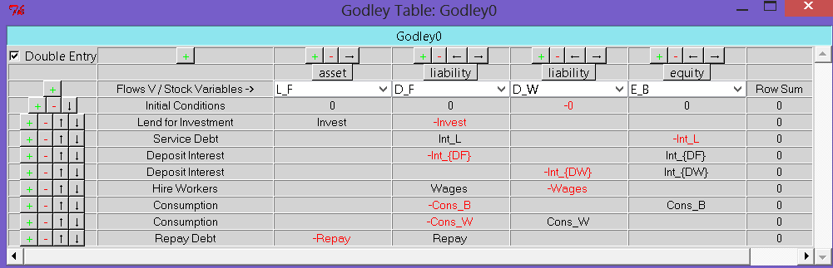
Figure 23: Overall private sector only model
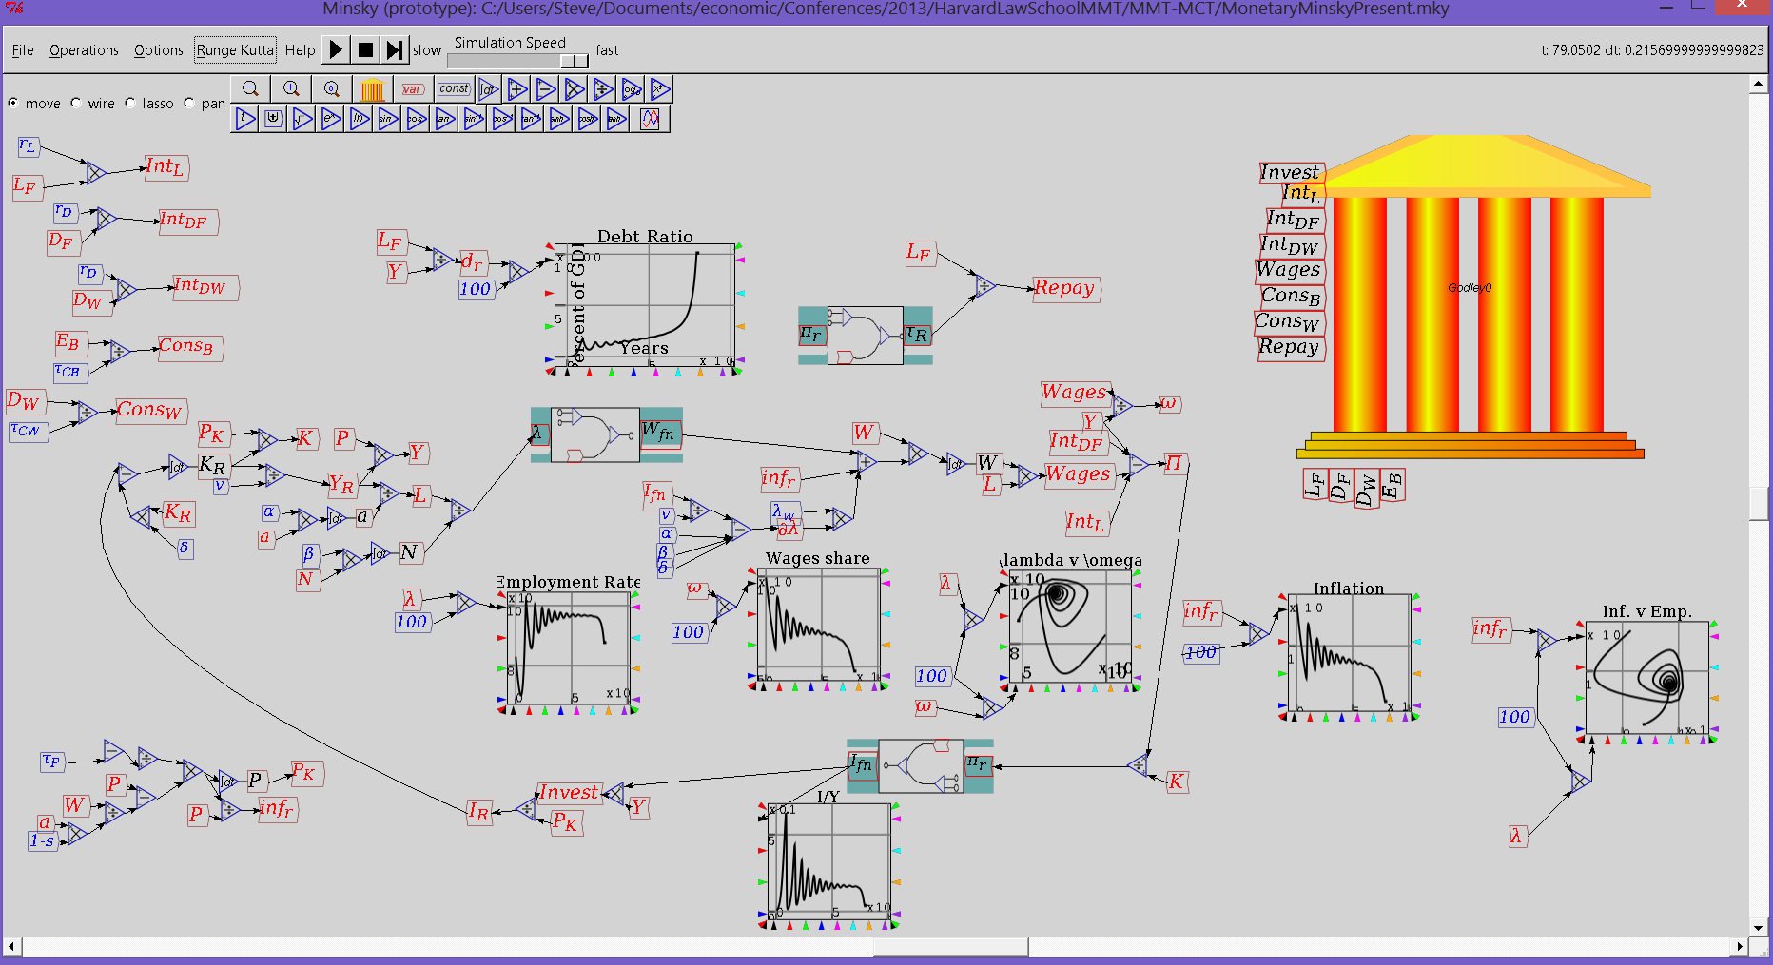
So too is the phenomenon which was a curious feature of that 1995 paper, and a historical fact now: the occurrence of an apparent “Great Moderation” immediately prior to the debt-deflationary collapse. A single-minded focus simply on the rate of unemployment (Figure 24) and the rate of inflation (Figure 25) sees instability giving way to tranquility. However, the debt to GDP ratio—the ignored factor in not only Neoclassical economics, but arguably also Post Keynesian economics prior to acknowledging that effective demand is income plus the change in debt—rises in a cyclical fashion before its exponential growth causes the economy to collapse.
Figure 24: Unemployment rate
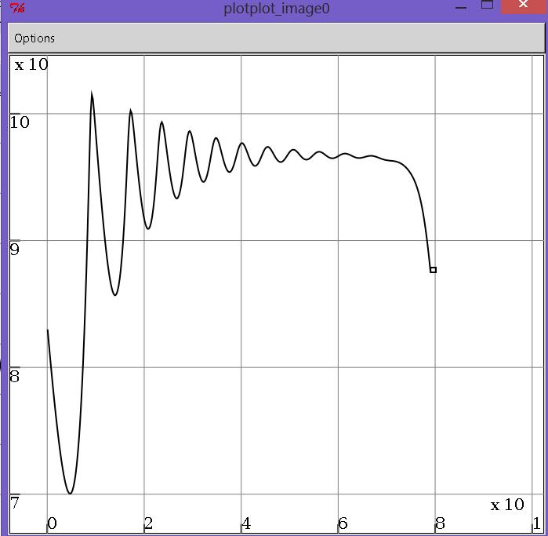
Figure 25: Inflation rate
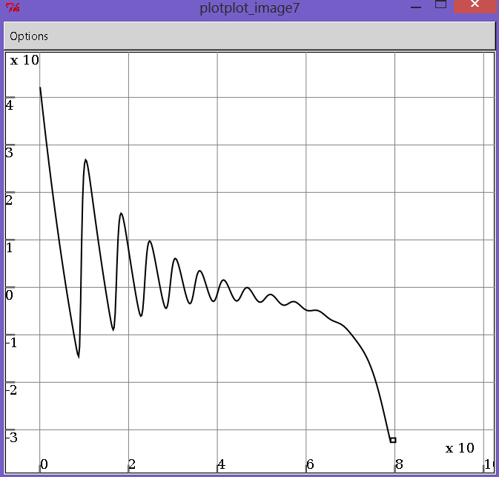
Figure 26: Debt to GDP ratio
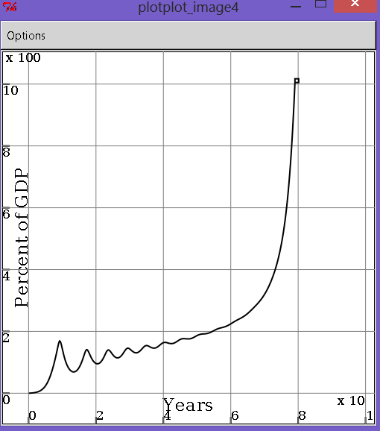
This is, as noted, an extremely stylized model—with perhaps the most important omission being the absence of bankruptcy, which in the real world prevents a total debt-induced collapse. But the basic qualitative characteristics of this extremely simple structural model capture the behavior of the US economy from 1993 till 2007 in an uncanny way.
Future development of this approach will involve adding additional aspects of reality, from bankruptcy to Ponzi financing of asset bubbles, and government counter-cyclical spending—all of which can be easily incorporated in the Minsky framework.

Conclusion
Monetary macroeconomics can do what Neoclassical non-monetary macroeconomics abjectly cannot: it can describe and model capitalism. It is now possible to transcend the historic practice of not including banks debt and money in macroeconomic models. The economic and financial crisis, and the failure of conventional economic theory to anticipate it, emphasizes that it is essential that we develop a strictly monetary approach to macroeconomics.

Appendix: Model equations (generated by Minsky)
Benes, J. and M. Kumhof (2012). The Chicago Plan Revisited. IMF Working Paper. Washington, IMF.
Bernanke, B. S. (2000). Essays on the Great Depression. Princeton, Princeton University Press.
Biggs, M. and T. Mayer (2010). "The Output Gap Conundrum." Intereconomics/Review of European Economic Policy 45(1): 11-16.
Biggs, M., T. Mayer, et al. (2010). "Credit and Economic Recovery: Demystifying Phoenix Miracles." SSRN eLibrary.
Carpenter, S. B. and S. Demiralp (2010). Money, Reserves, and the Transmission of Monetary Policy: Does the Money Multiplier Exist? Finance and Economics Discussion Series. Washington, Federal Reserve Board.
Eggertsson, G. B. and P. Krugman (2012). "Debt, Deleveraging, and the Liquidity Trap: A Fisher-Minsky-Koo approach." Quarterly Journal of Economics 127: 1469–1513.
Fisher, I. (1933). "The Debt-Deflation Theory of Great Depressions." Econometrica 1(4): 337-357.
Godley, W. and M. Lavoie (2005). "Comprehensive Accounting in Simple Open Economy Macroeconomics with Endogenous Sterilization or Flexible Exchange Rates." Journal of Post Keynesian Economics 28(2): 241-276.
Goodwin, R. M. (1967). A growth cycle. Socialism, Capitalism and Economic Growth. C. H. Feinstein. Cambridge, Cambridge University Press: 54-58.
Graziani, A. (1995). The Theory of the Monetary Circuit. The money supply in the economic process: A Post Keynesian perspective. M. Musella and C. Panico. Aldershot, U.K, Elgar Reference Collection. International Library of Critical Writings in Economics. 60: 516-541.
Greenspan, A. (2013). Greenspan: Ignore The Economy, "Only The Stock Market Matters". Zerohedge. T. Durden. New York, Tyler Durden.
Guerrero, O. A. and R. L. Axtell (2013). "Employment Growth through Labor Flow Networks." PLoS ONE 8(5): e60808.
Holmes, A. R. (1969). Operational Constraints on the Stabilization of Money Supply Growth. Controlling Monetary Aggregates. F. E. Morris. Nantucket Island, The Federal Reserve Bank of Boston: 65-77.
Ireland, P. N. (2011). "A New Keynesian Perspective on the Great Recession." Journal of Money, Credit, and Banking 43(1): 31-54.
Keen, S. (1995). "Finance and Economic Breakdown: Modeling Minsky's 'Financial Instability Hypothesis.'." Journal of Post Keynesian Economics 17(4): 607-635.
Keen, S. (2011). Debunking economics: The naked emperor dethroned? London, Zed Books.
Keynes, J. M. (1936). The general theory of employment, interest and money. London, Macmillan.
Krugman, P. (2012). End this Depression Now! New York, W.W. Norton.
Kydland, F. E. and E. C. Prescott (1990). "Business Cycles: Real Facts and a Monetary Myth." Federal Reserve Bank of Minneapolis Quarterly Review 14(2): 3-18.
Moore, B. J. (1979). "The Endogenous Money Stock." Journal of Post Keynesian Economics 2(1): 49-70.
Moore, B. J. (1983). "Unpacking the Post Keynesian Black Box: Bank Lending and the Money Supply." Journal of Post Keynesian Economics 5(4): 537-556.
Moore, B. J. (1988). "The Endogenous Money Supply." Journal of Post Keynesian Economics 10(3): 372-385.
Moore, B. J. (1988). Horizontalists and Verticalists: The Macroeconomics of Credit Money. Cambridge, Cambridge University Press.
Moore, B. J. (1997). "Reconciliation of the Supply and Demand for Endogenous Money." Journal of Post Keynesian Economics 19(3): 423-428.
Moore, B. J. (2001). Some Reflections on Endogenous Money. Credit, interest rates and the open economy: Essays on horizontalism. L.-P. Rochon and M. Vernengo. Edward Elgar, Cheltenham: 11-30.
O'Brien, Y.-Y. J. C. (2007). "Reserve Requirement Systems in OECD Countries." SSRN eLibrary.

Plus the banking sector’s equity, as I illustrate later.
All variables are shown as positives in this system dynamics view, since it looks at the economy as a whole, rather than from the point of view of any single agent.
In the table this would show up as a positive number, since again this table portrays the reserves of private banks as liabilities of the Central Bank, and hence as negative quantities.
The model also uses time constants as parameters, so that parameter for the rate of lending τ_{L} has the value of 7 (years)—indicating that if this inflow kept up at its initial rate and was the only outflow from the account (with no other inflows) then lending would empty Patient’s account after 7 years.
This would be determined by system dynamics in a more complete and explicit model.

